Ideation Phase

Define the Problem Statements

|  |  |
| --- | --- |
| Date | 1 October 2022 |
| Team ID | PNT2022TMID34283 |
| Project Name | Real-Time Communication System Powered by  AI for Specially Abled |
| Maximum Marks | 2 Marks |

# Customer Problem Statement:

To address the challenges faced by deaf-mute persons in their daily life so they can interact with Normal people feel hopeful. Converting sign language into human hearing speech and vice versa Using Convolutional Neural Network in the desired language. Deploying our solution to provide a Faster response in the desired language.

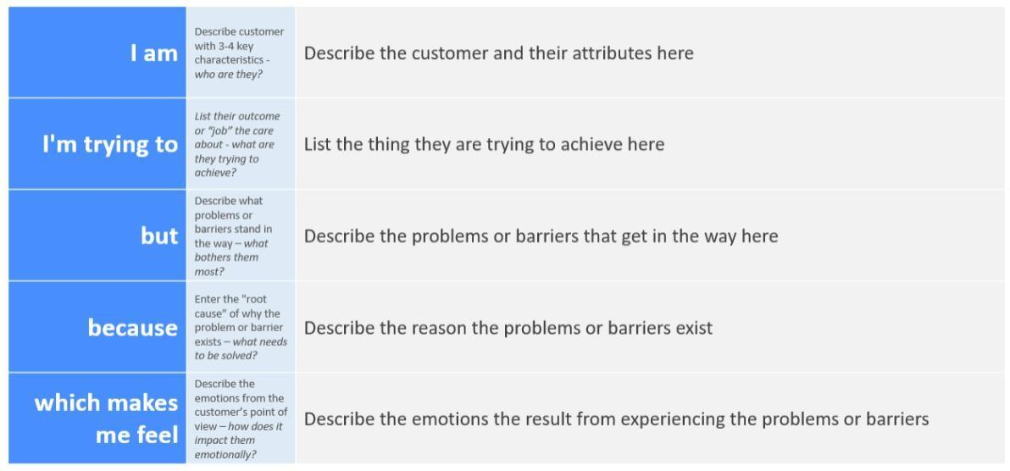

Till now there was no application to convert their speech to sign language accurately for people to understand.

When they want to communicate their thoughts or an emergency or immediate message to normal people.

Convert sign language to the voice heared by normal people & also speech convert to sign language for deaf and mute people

Very sad and sometimes depressed because of not able to communicate with people.

The customers who is specially abled people because I can’t speak and I can’t hear.

Reference: <https://miro.com/templates/customer-problem-statement/>

# Example:

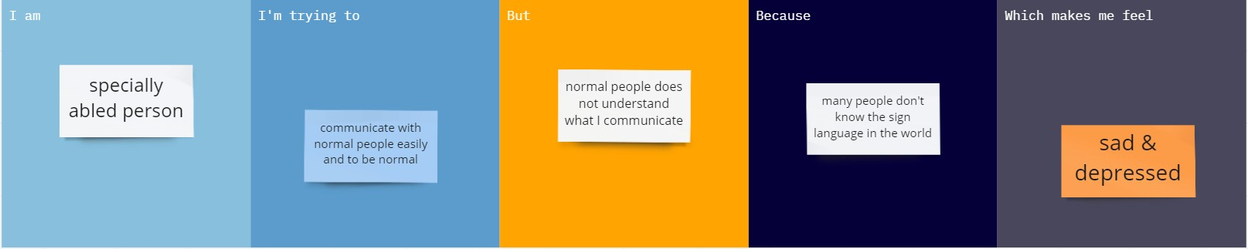

|  |  |  |  |  |  |
| --- | --- | --- | --- | --- | --- |
| **Problem Statement (PS)** | **I am (Customer)** | **I’m trying to** | **But** | **Because** | **Which makes me feel** |
| PS-1 | Specially abled Person who is speech impaired | Communicate with normal people and make them to understand my  sign language | I cannot communicate to them what I think. | Normal people don’t understand sign language. | Sad and depressed . |
| PS-2 | Deaf person | Understand what others speak . | I cannot hear  what others speaking. | I have hearing impairment. | Not to be like a normal person. |